EXP NO 2: CREATE A SIMPLE CLOUD SOFTWARE APPLICATION FOR FLIGHT RESERVATION SYSTEM USING ANY CLOUD SERVICE PROVIDER TO DEMONSTRATE SAAS.

AIM: To create a simple cloud software application for flight reservation system using any cloud service provider to demonstrate saas.

PROCEDURE:

Step1: go to zoho.com
Step 2: login to the zoho.com
Step 3: Create an application and open it.
Step 4: give a name as Flight Reservation to the application and add a form in the name Booking Details application.
Step 5: Add the required fields like name,date,phone number,email,from,to..etc.
Step 6:Click done and run the application.

OUTPUT:

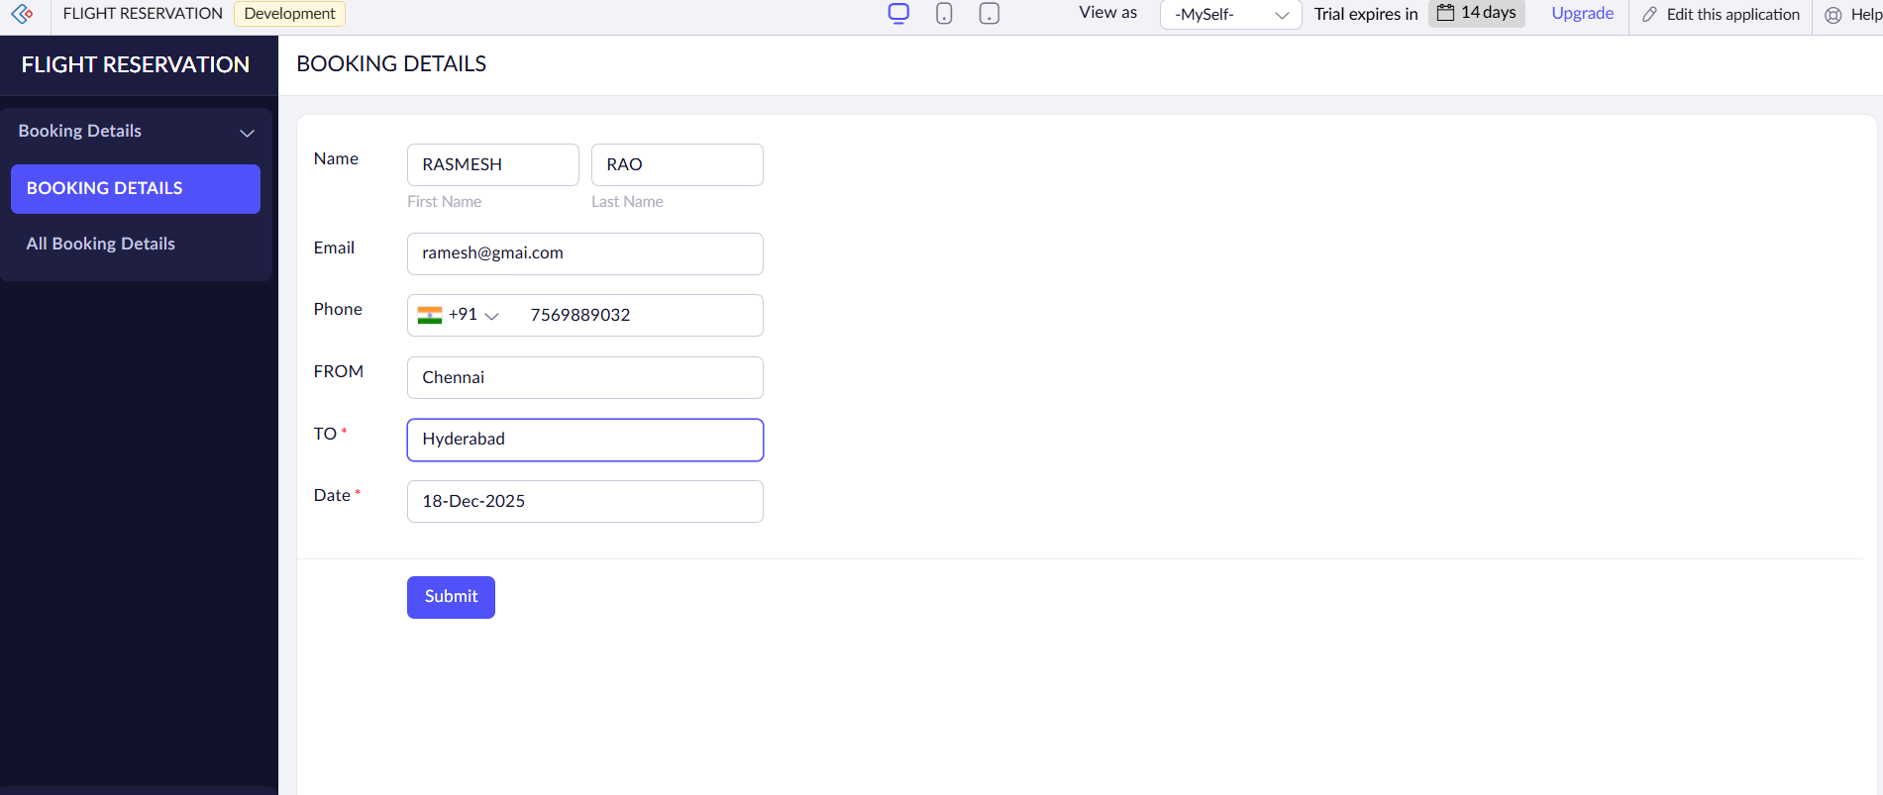
RESULT:

We have sucessfully created a simple cloud software application for flight reservation system using any cloud service provider to demonstrate saas.

